EXPERIMENT 1

AIM:
Demonstrate inline, internal, and external JavaScript; use console methods; create a web[age showing user info and a welcome.

Software/Tools Required:
- Visual Studio Code (VS Code)
- Web Browser (Google Chrome/Microsoft Edge)
- HTML
- JavaScript (ES6)

Theory:
JavaScript is a scripting language used to make web pages interactive and dynamic. It can be added to an HTML page in three ways: inline JavaScript (inside HTML elements), internal JavaScript (inside the <script> tag, and external JavaScript (in a separate .js file linked to the HTML page). JavaScript also provides console methods such as console.log(), console.warm(), and console.error() for debugging and displaying messages. In this experiment, JavaScript is used to display user information and a welcome message on a webpage while demonstrating different ways of adding JavaScript to HTML.

Output:
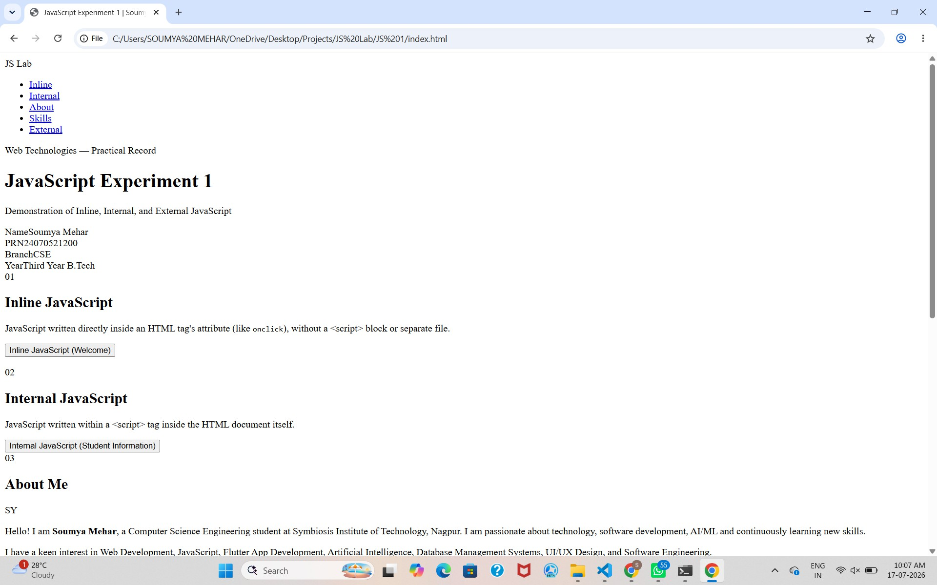

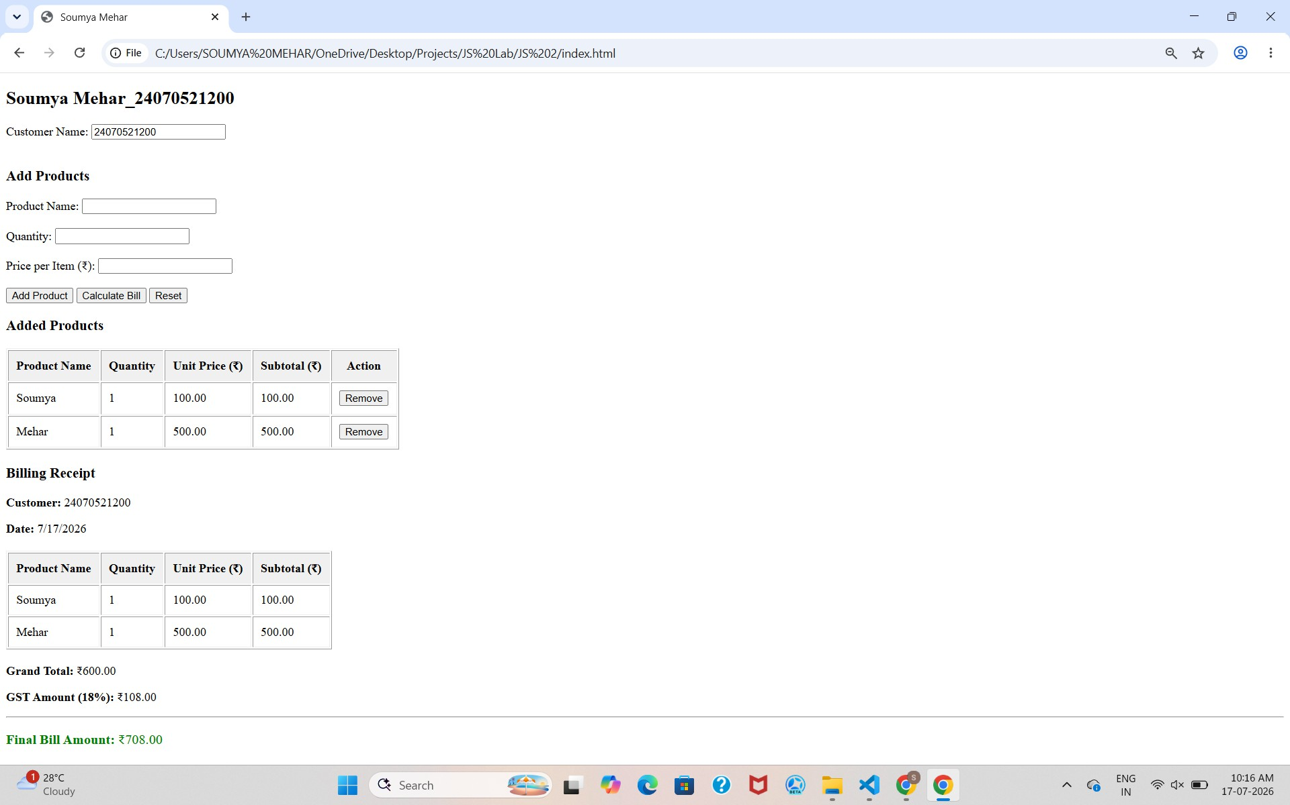

Result:
Successfully implemented a billing calculator using JavaScript ES6 features, including var, let, const, template literals, and destructuring, to calculate and display billing details accurately.

CASE STUDY 1

AIM:
Create a webpage for the college department and link the student information and write a JavaScript program to display “Welcome to SIT Nagpur”.

PROGRAM CODE:
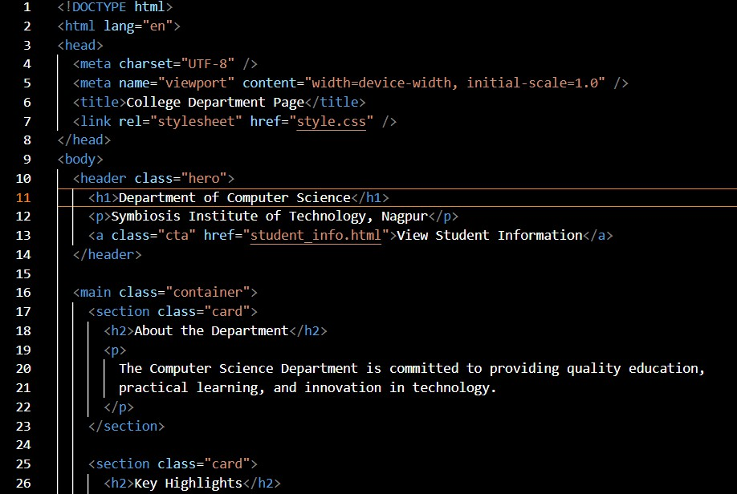

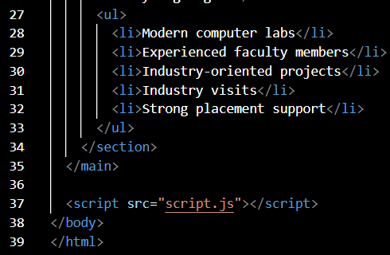

OUTPUT:
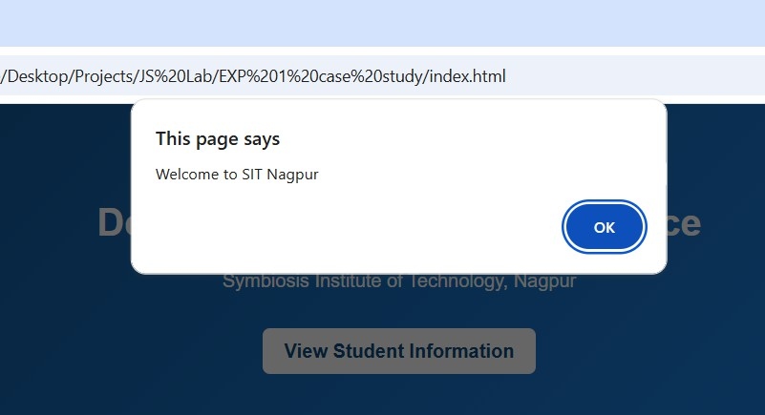

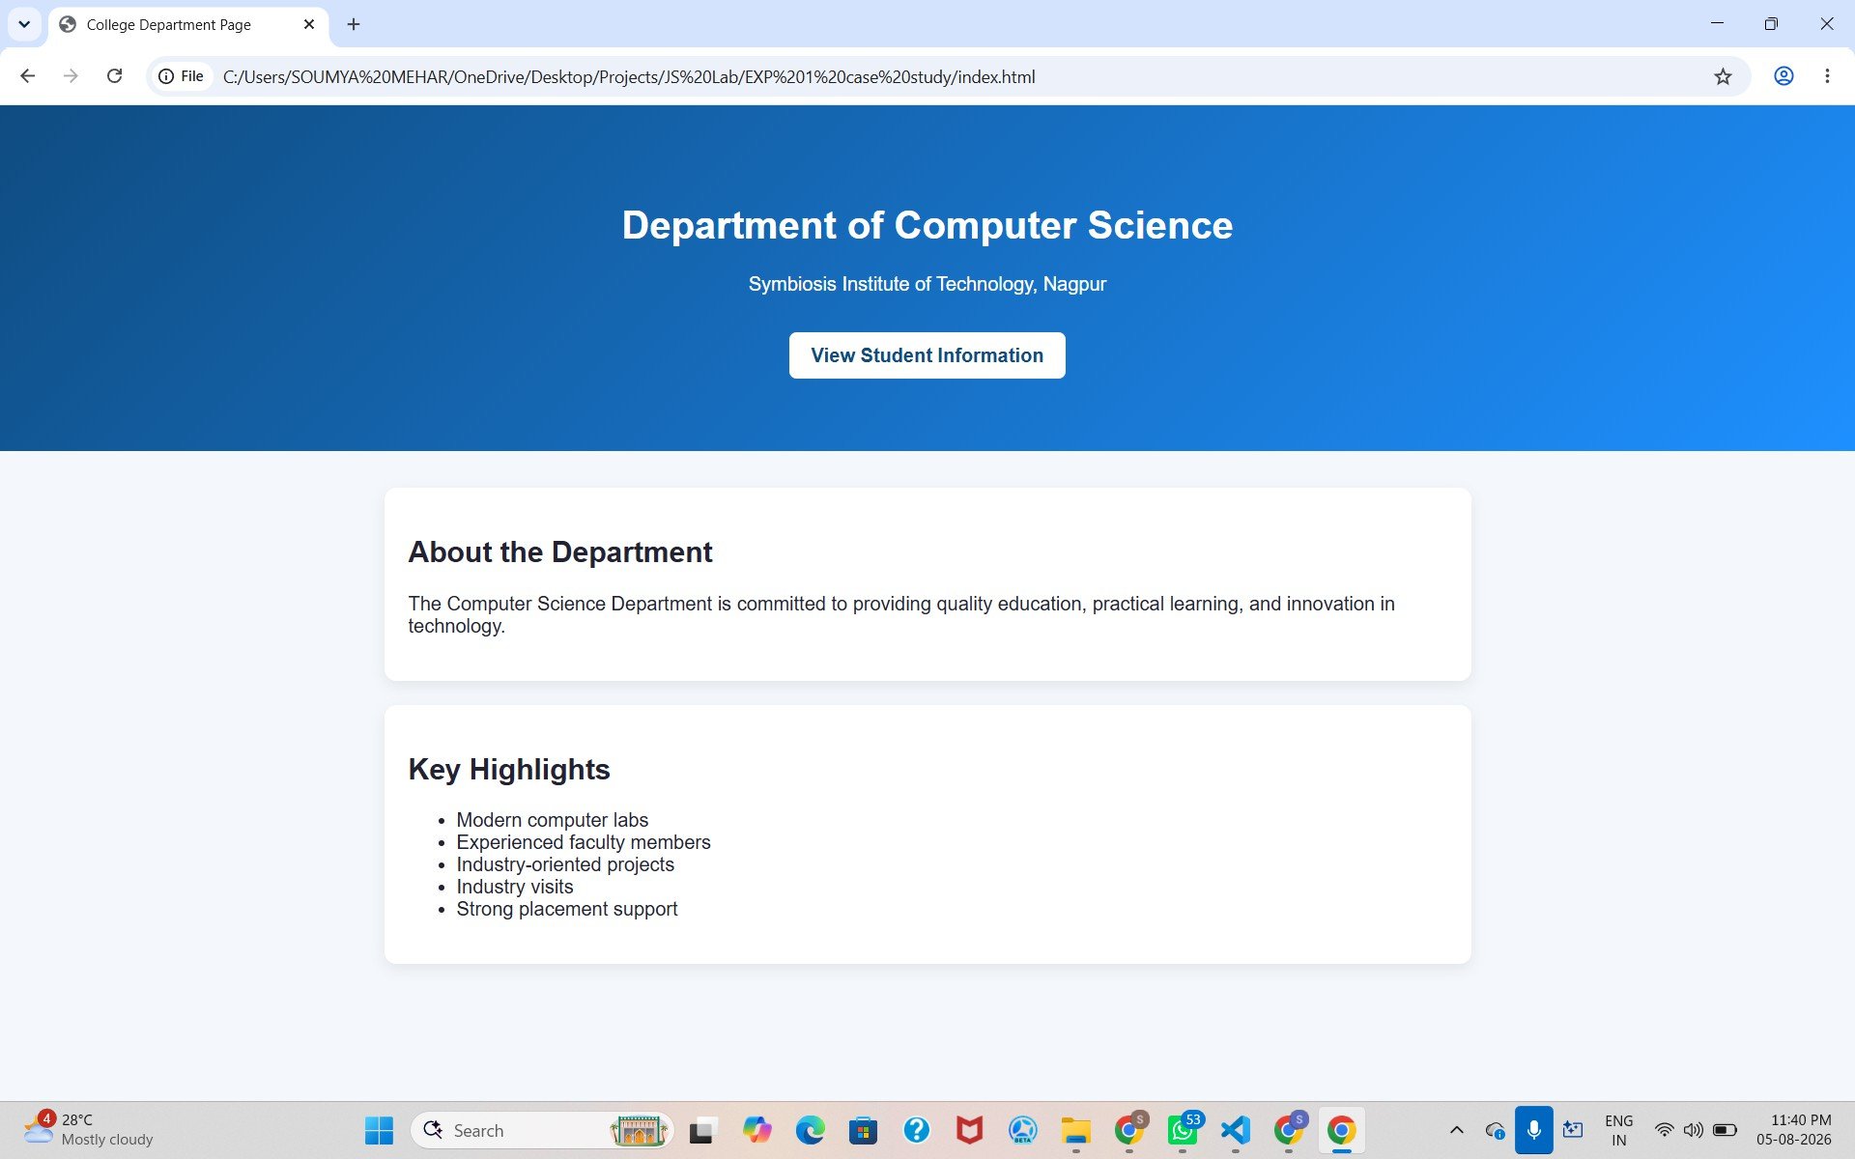

RESULT:
A webpage for the college department was successfully created using HTML, CSS, and JavaScript. Student information was linked and displayed correctly, and the JavaScript program successfully displayed the message "Welcome to SIT Nagpur" on the webpage. Thus, the aim of creating a college department webpage and implementing JavaScript functionality was achieved successfully.

EXPERIMENT 2

AIM:
To use var, let, and const, and demonstrate ES6 features like template literals and destructuring by building a billing calculator.

Software/Tools Required:
- Visual Studio Code (VS Code)
- Web Browser (Google Chrome/Microsoft Edge)
- HTML5
- JavaScript (ES6)

Theory:
JavaScript ES6 (ECMAScript 2015) introduced several modern features that make programming more efficient, readable, and easier to maintain. Among these features are var, let, and const, which are used for variable declaration. The var keyword has function scope and allows variables to be redeclared and updated. The let keyword provides block scope and allows variables to be updated but not redeclared within the same scope. The const keyword is also block-scoped and is used to declare constants whose values cannot be reassigned after initialization.
Template literals are another important ES6 feature that simplify string creation and formatting. They use backticks ( ) instead of quotation marks and allow variables and expressions to be embedded directly into strings using ${expression}. This eliminates the need for string concatenation and improves code readability.
Destructuring is a convenient JavaScript feature that enables the extraction of values from arrays or properties from objects into separate variables. It reduces repetitive code, makes variable assignment more concise, and improves code clarity, especially when working with complex data structures.

In this experiment, a billing calculator is developed using HTML and JavaScript. The application accepts user inputs such as product details, quantity, and price, and performs calculations to determine the total bill. Variables are declared using var, let, and const wherever appropriate, while template literals are used to display formatted billing information. Destructuring is applied to efficiently access and manage object or array values. This experiment demonstrates the practical implementation of modern JavaScript features in developing a simple, interactive, and user-friendly web application.

Output:

Result:
Successfully implemented a billing calculator using JavaScript ES6 features, including var, let, const, template literals, and destructuring, to calculate and display billing details accurately.

CASE STUDY 2

AIM:
Develop the webpage for an online shopping website with using html,css and html tags and calculate bill,customer name,mobile no,invoice no,product no,quantity(kg),rate per kg,discount,GST,packing charges,payment mode(cash/card/UPI), Membership(yes/no).

PROGRAM CODE:
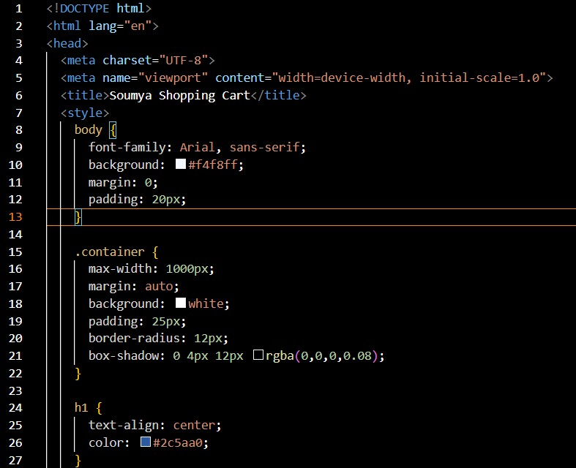

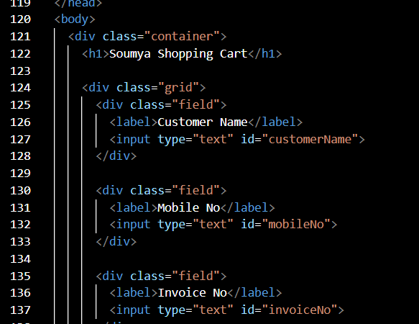

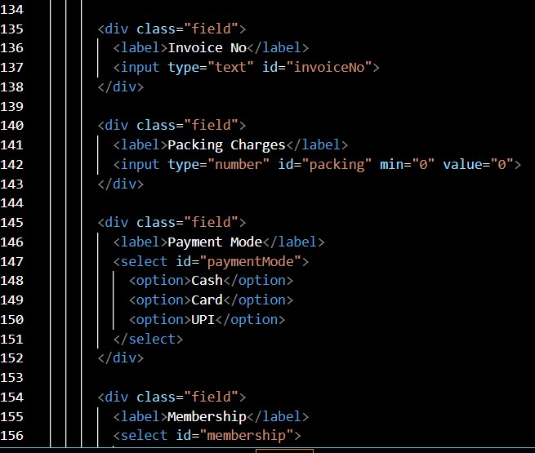

OUTPUT:
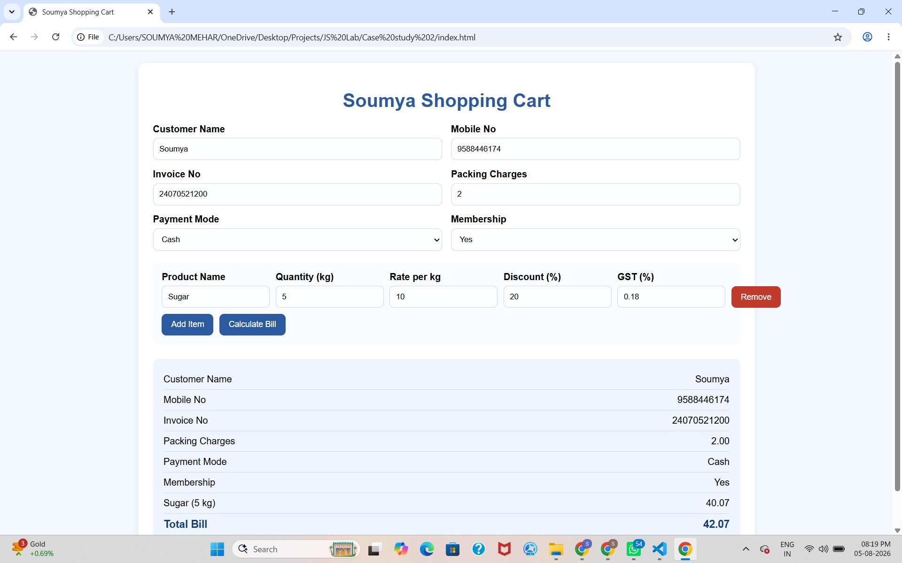

RESULT:
The online shopping billing webpage was successfully developed using HTML, CSS, and JavaScript. The program accepted customer and product details, calculated the total bill including discount, GST, and packing charges, and displayed the final invoice correctly. It demonstrated the use of user input, arithmetic calculations, objects, template literals, and object destructuring in JavaScript.

EXPERIMENT 3

AIM:
To implement JavaScript control structures and form validation by creating a grading system based on user-entered marks.

Software/Tools Required:
- Visual Studio Code (VS Code)
- Web Browser (Google Chrome/Microsoft Edge)
- HTML5
- JavaScript (ES6)

Theory:
JavaScript is a widely used scripting language that enables interactive and dynamic behavior on web pages. One of its key features is the use of control structures, such as if, else if, else, and switch, which allow programs to make decisions based on specified conditions. These control structures help in executing different blocks of code depending on the values provided by the user, making applications more intelligent and responsive.
Another important concept in web development is form validation, which ensures that user input is accurate, complete, and within the expected range before it is processed. Validation helps prevent invalid or incomplete data from affecting the application's functionality. It checks conditions such as empty input fields, non-numeric values, and marks entered outside the valid range (0–100). This improves data integrity and enhances the overall user experience.
In this experiment, a grading system is developed using HTML and JavaScript. The user enters marks for different subjects through a form, and JavaScript validates the input before performing calculations. After successful validation, the program computes the total marks, percentage, grade, and pass/fail status. The grade is determined using conditional statements based on predefined percentage ranges, while the pass/fail status is decided according to the minimum passing criteria. This experiment demonstrates the

practical application of JavaScript control structures and form validation in building an interactive and reliable web application.

Output:
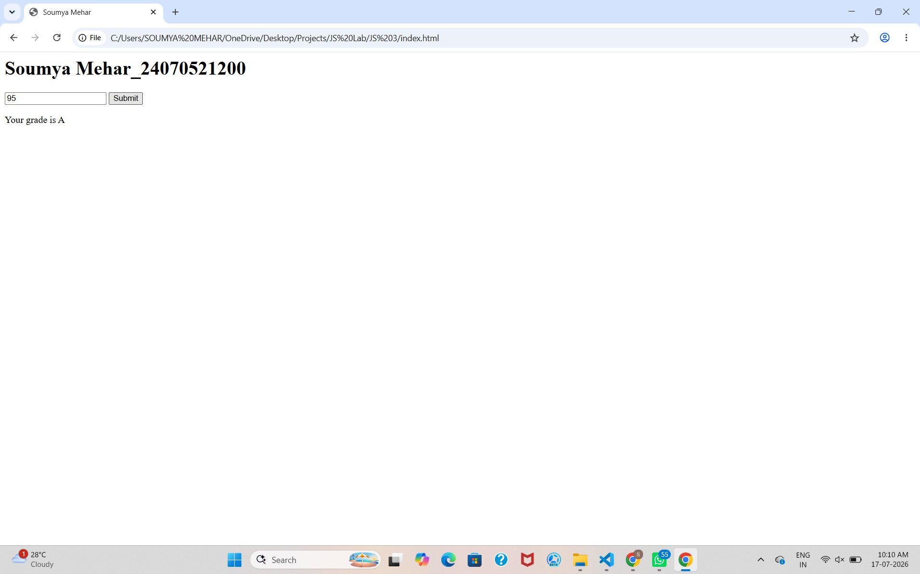

Result:
Successfully implemented JavaScript control structures and form validation to create a grading system that validates user input, calculates the total marks, percentage, grade, and pass/fail status accurately.

CASE STUDY 3

AIM:
Scholarship Eligibility,A college awards scholarships based on marks. Below 50-Not Eligible, 50-69-Bronze,70-84-Silver,85-94-Gold,95-100-Platinum.

PROGRAM CODE:
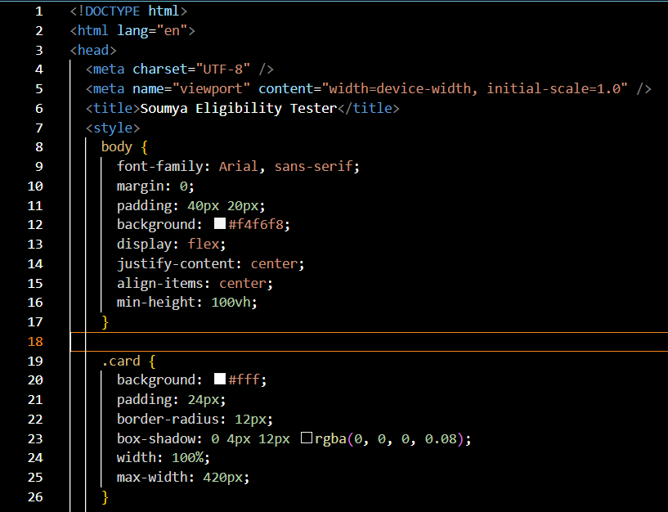

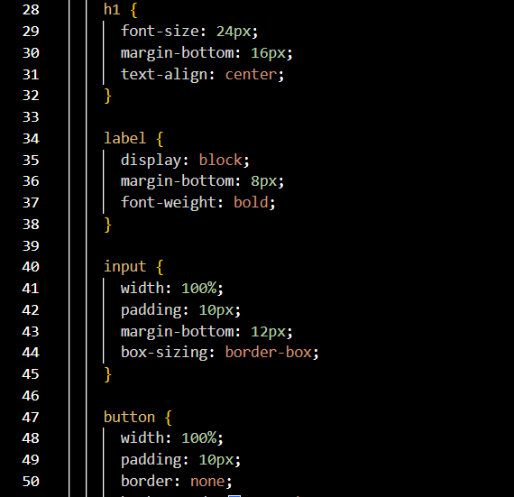

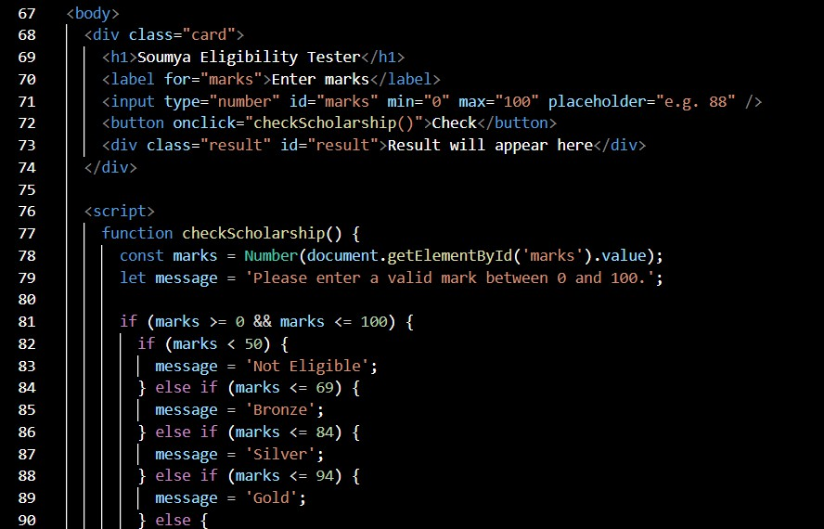

OUTPUT:
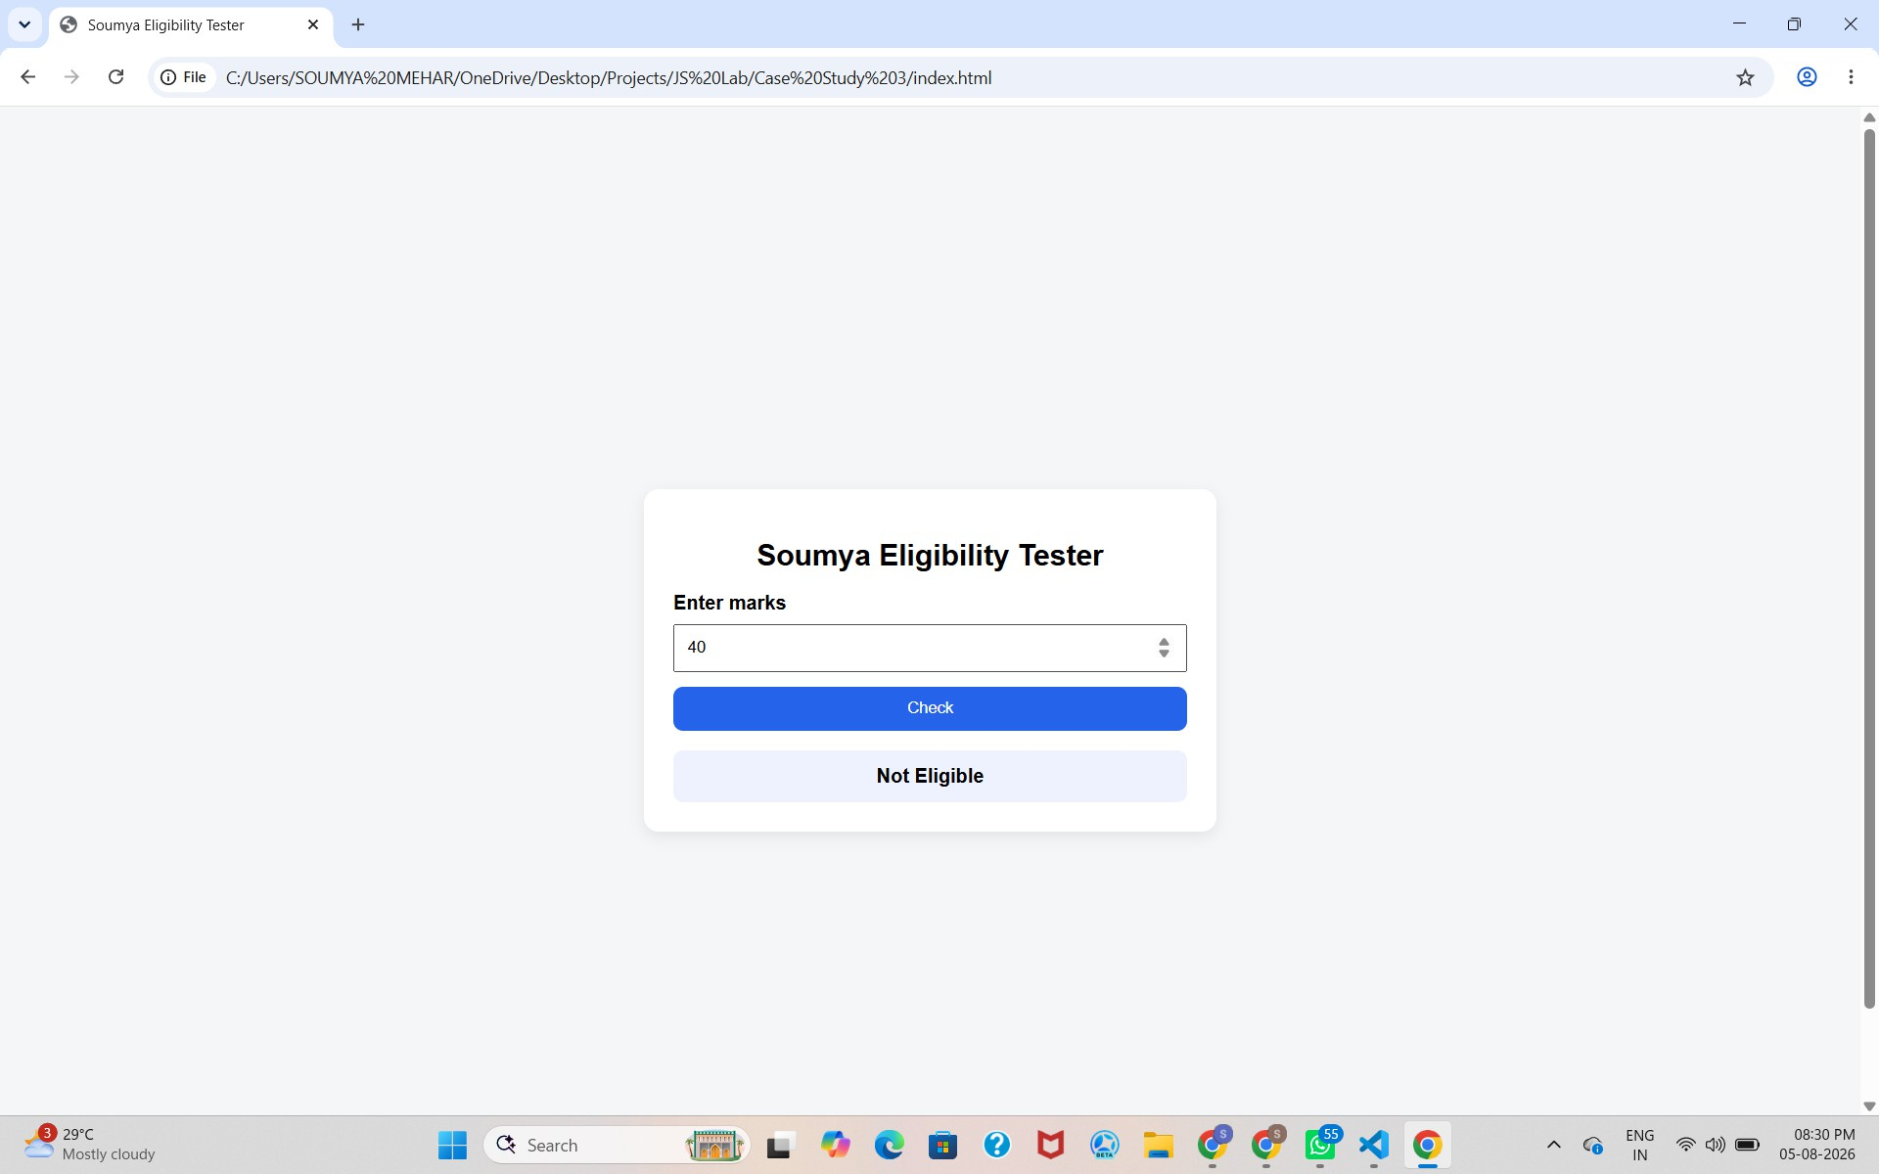

RESULT:
The Scholarship Eligibility was successfully implemented using JavaScript. The program validated the user input, assigned eligibility marks using if-else control structures, and displayed the correct Eligibility awards based on the entered marks. It effectively demonstrated the use of control structures and form validation in web development.

EXPERIMENT 4

AIM:
Use function types, scope and closures; apply try-catch; build a palindrome checker

Software/Tools Required:
- Visual Studio Code (VS Code)
- Web Browser (Google Chrome/Microsoft Edge)
- HTML
- JavaScript (ES6)

Theory:
A palindrome is a word, number, or sentence that reads the same forward and backward, such as MADAM, LEVEL, and 121. A palindrome checker is a program that checks whether the given input is a palindrome or not by comparing the original string with its reverse.
In JavaScript, different types of functions, such as function declarations, function expressions, and arrow functions, can be used to implement the palindrome checker. Variable scope determines where variables can be accessed in the program, while closures allow an inner function to access variables from its outer function.
The try-catch statement is used for exception handling and helps manage errors, such as invalid or empty input, without stopping the execution of the program. Thus, a palindrome checker demonstrates the concepts of functions, scope, closures, and error handling in JavaScript.

Output:
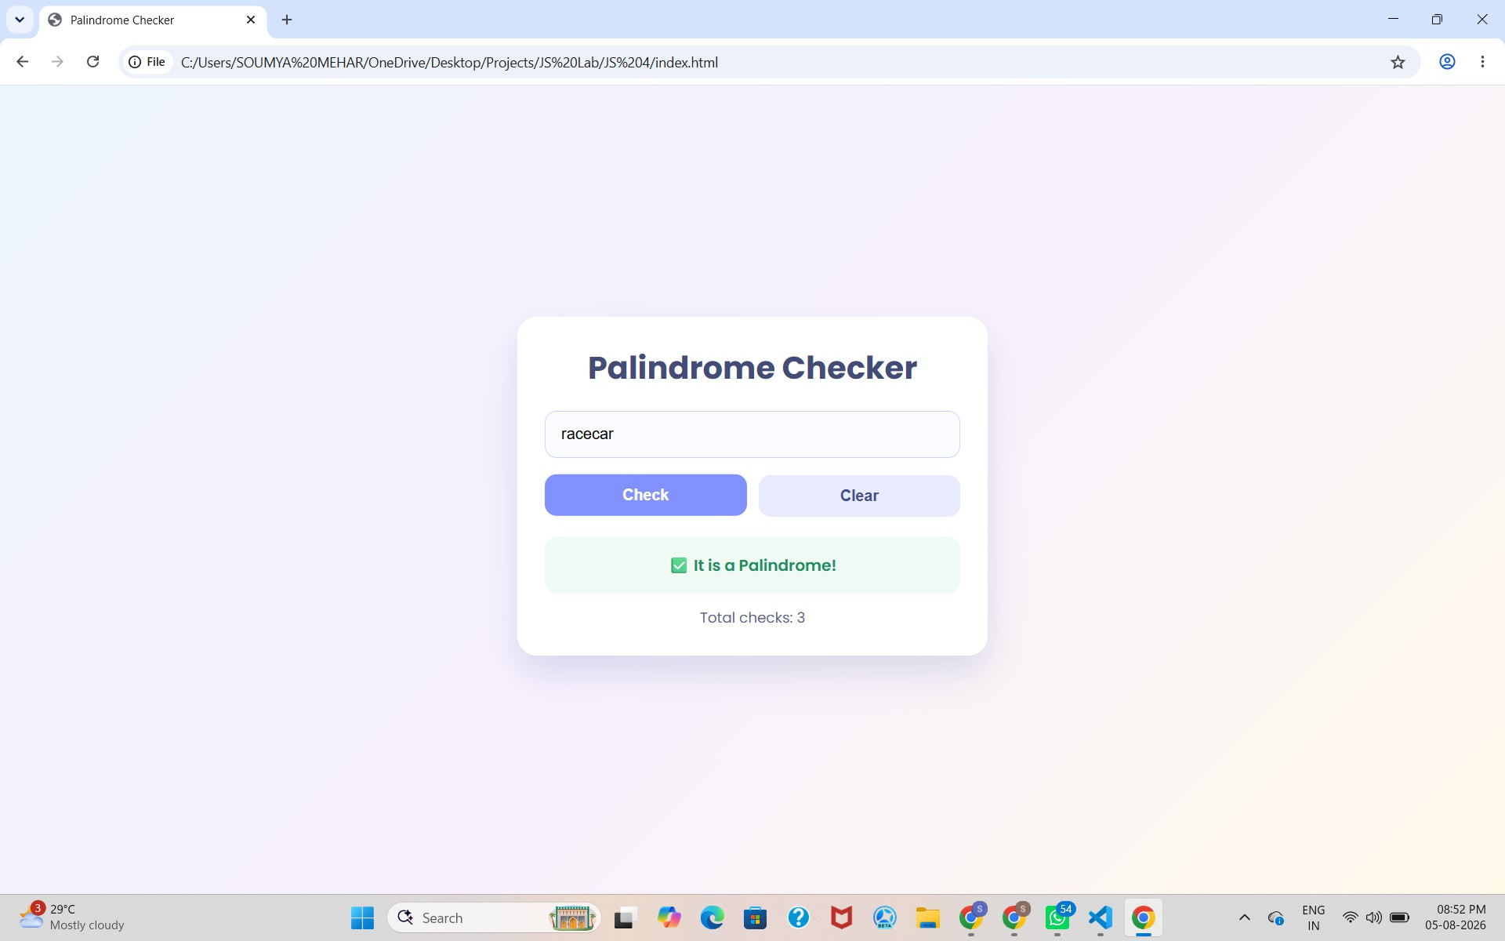

Result:
Successfully implemented a Palindrome detector using JavaScript ES6 features, including var, let, const, template literals, and destructuring, to find and display whether the given text or number is a palindrome or not.

CASE STUDY 4

AIM:
The ATM system verifies if the pin is palindrome. If the palindrome displays a security message. To implement this create a function to reverse the entered pin number and another function to check if it is palindrome. use function declaration, function expression, arrow function and demonstrate scope and closure concepts.

PROGRAM CODE:
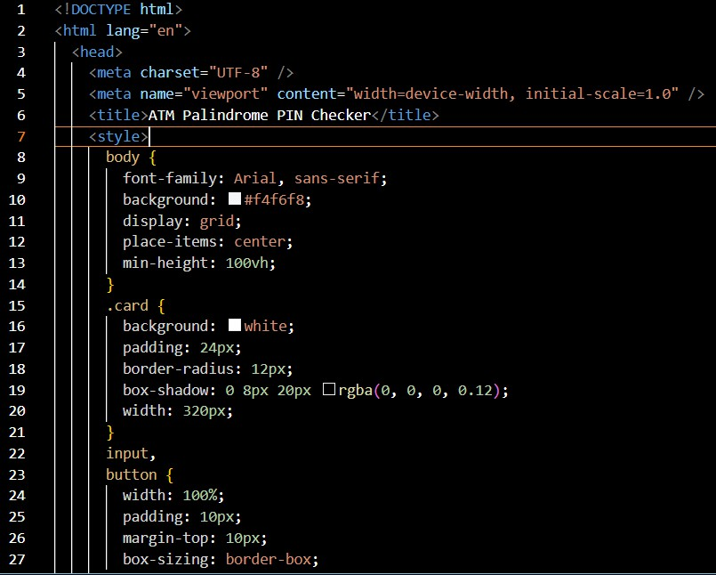

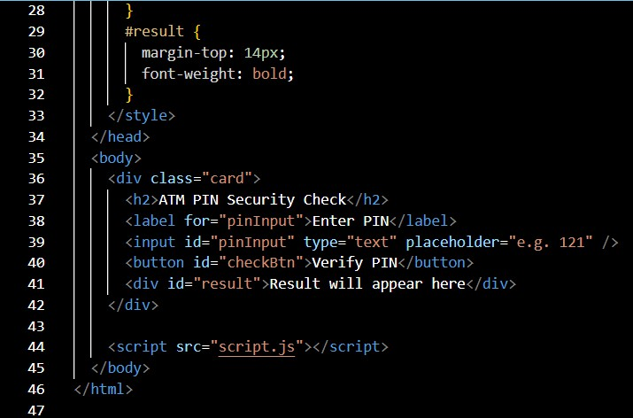

OUTPUT:
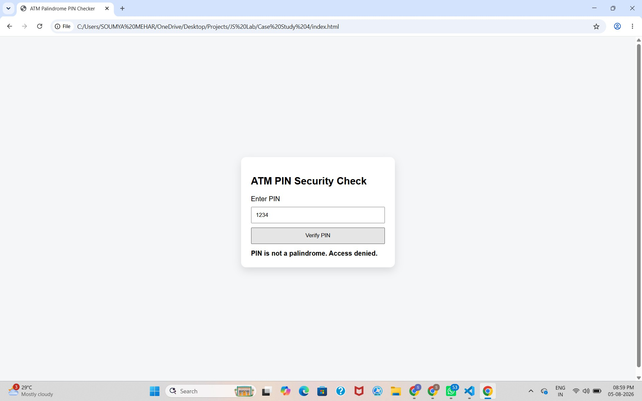

RESULT:
Successfully implemented a ATM pin Palindrome detector using JavaScript ES6 features, including var, let, const, template literals, and destructuring, to find and display whether the given ATM pin is a palindrome or not.

EXPERIMENT 5
AIM:
Apply array methods and object handling. Create a cart total calculator with discount logic.
THEORY:
A Cart Total Calculator in JavaScript is used to calculate the total cost of items added to a shopping cart and apply discounts based on the total amount. Each cart item can be represented as an object containing properties such as item name, price, and quantity. Multiple objects can be stored in an array.
JavaScript array methods such as map(), reduce(), and filter() can be used to process cart items efficiently. The reduce() method is commonly used to calculate the total price, while map() can be used to modify or calculate values for each item. Object handling allows the program to access and manipulate item properties.
After calculating the subtotal, conditional statements are used to apply discount logic according to predefined conditions. The final amount is calculated by subtracting the discount from the subtotal. This demonstrates the practical use of arrays, objects, array methods, and decision-making in JavaScript.

OUTPUT:
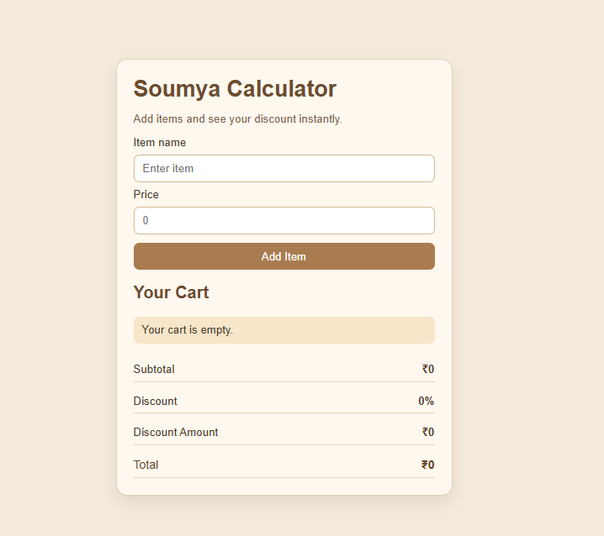
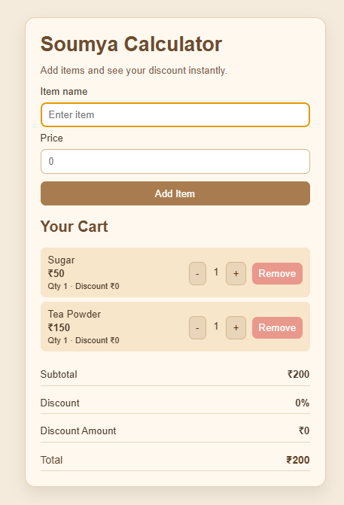
RESULT:
Successfully implemented JavaScript control structures and form validation to create a calculator that validates user input, calculates the total price with GST tax and number of items input accurately.

CASE STUDY 5

AIM:

Create an array of numbers and find the maximum and minimum values.

PROGRAM CODE:

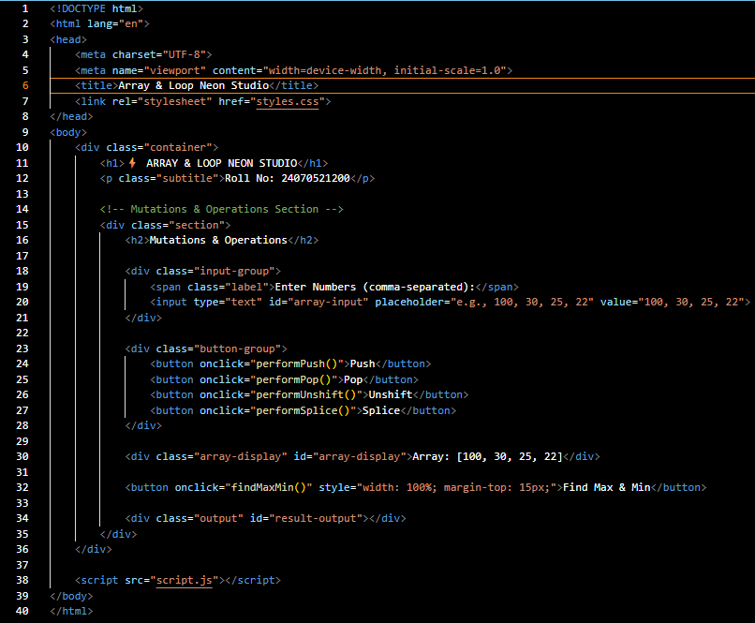
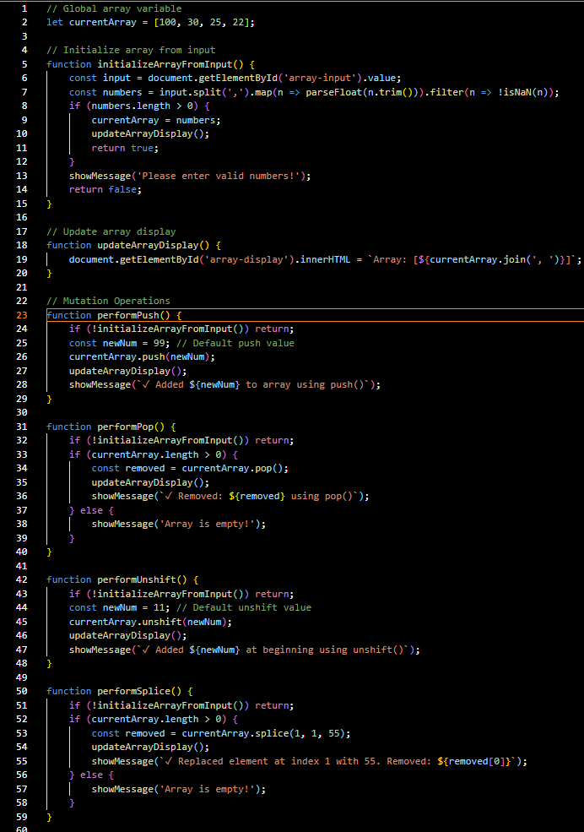
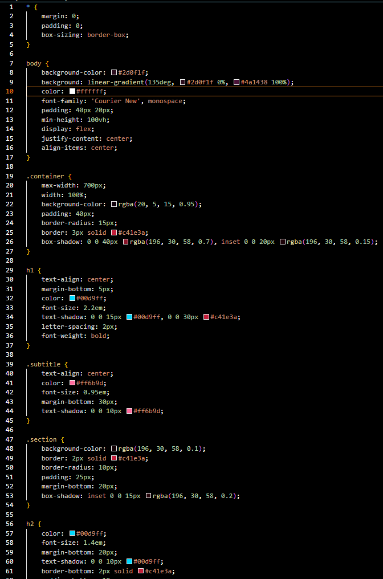

OUTPUT:

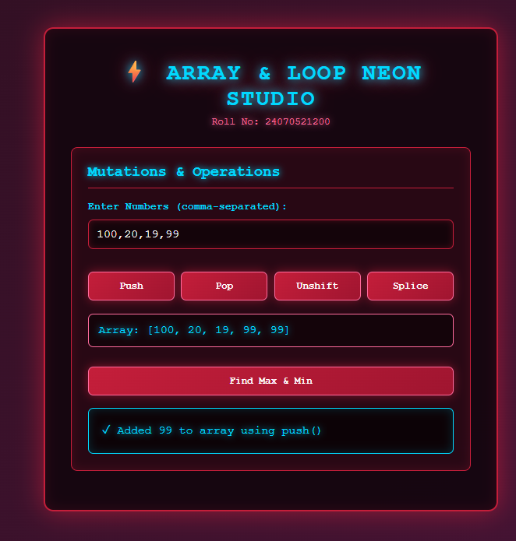

RESULT:

Thus, the functioning of JavaScript arrays and loops was studied and implemented successfully. Various array methods such as push(), pop(), shift(), unshift(), splice(), slice(), map(), filter(), reduce(), and forEach() were used to manipulate and process array elements. The maximum and minimum values were also successfully found from an array of numbers.

EXPERIMENT 6

AIM:

Use string function and regex for email validation, data extraction and text analysis.

THEORY:

This demonstrates basic web development and text manipulation using HTML, CSS, and JavaScript. The user interface takes string inputs and processes them dynamically in real time using DOM manipulation and standard string methods. Regular Expressions (Regex) are used to search, pattern-match, and extract valid email addresses from unformatted text blocks.

Built-in string methods like .toUpperCase(), .toLowerCase(), and .length enable instant case conversion and character counting. Word counts and targeted keyword tracking (e.g., detecting "welcome" and counting "email") are performed by splitting strings and using pattern matching (RegExp.prototype.test()) and String.prototype.match().

Overall, the project demonstrates client-side data validation, text processing, and dynamic UI rendering without requiring page reloads.

OUTPUT:

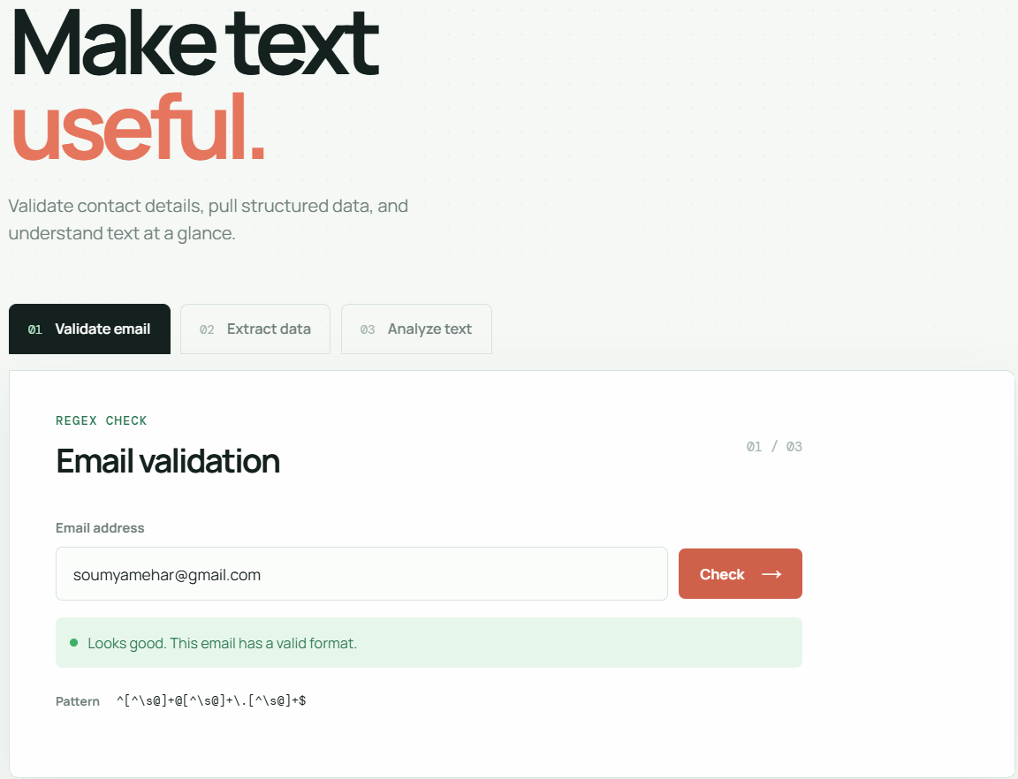
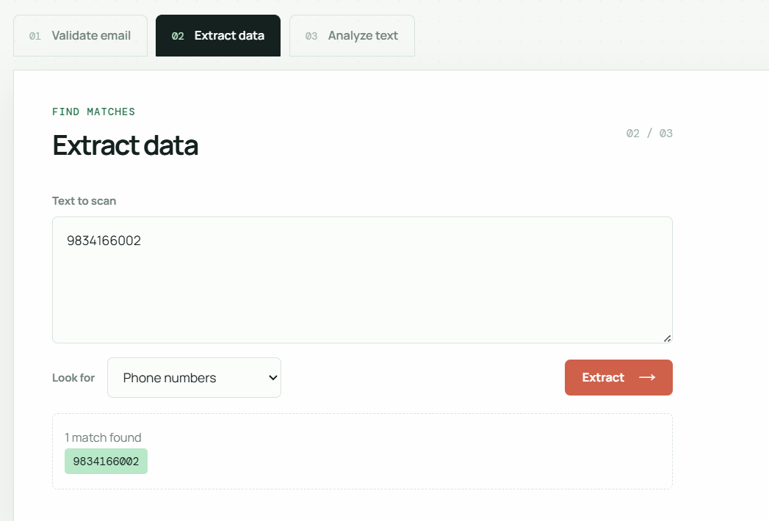
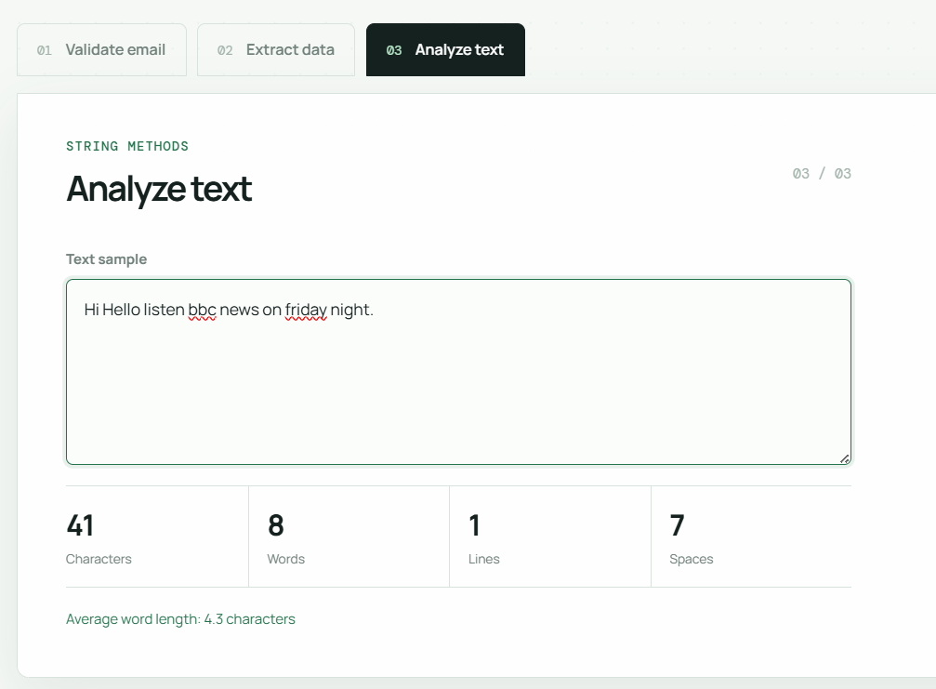

RESULT:

The developed web application successfully processes user input in real time. It accurately measures total character length and word count, detects the presence of the word "welcome", and counts occurrences of the word "email". Furthermore, the uppercase and lowercase transformation buttons dynamically reformat the text, while the Regular Expression engine correctly extracts all valid email addresses embedded in the text block and validates individual email formats.

CASE STUDY 6

AIM:

To perform basic string operations ; to reverse a string and count number of vowels in a paragraph.

PROGRAM CODE:

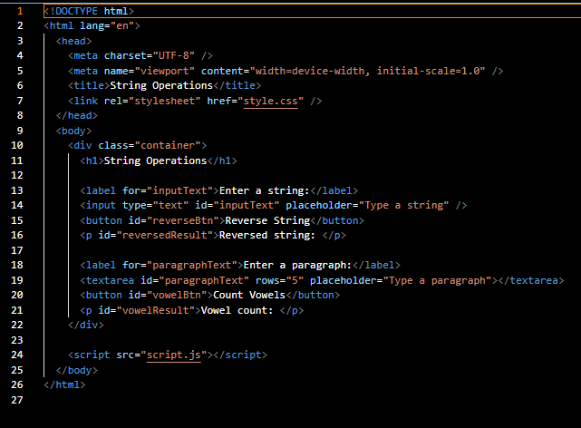
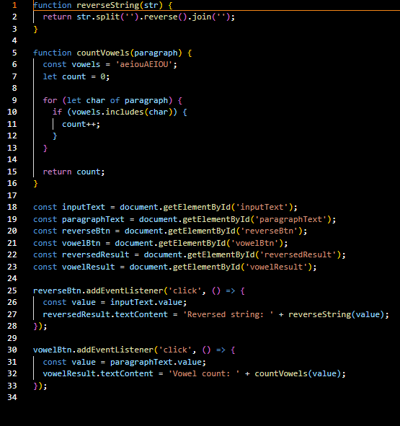
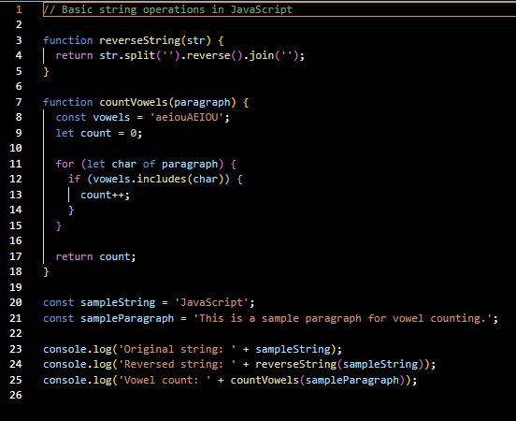

OUTPUT:

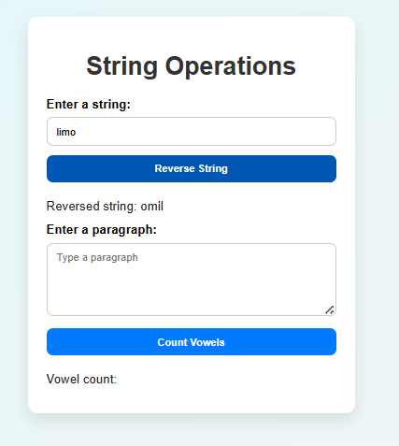
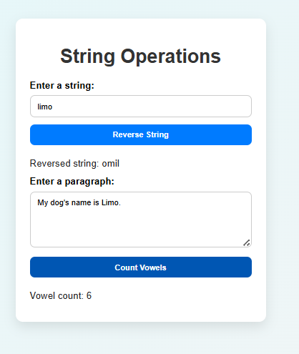

RESULT:

The JavaScript string operations such as substring, indexOf, split, and replace were successfully performed on the given string. The practical helped in understanding how JavaScript string methods can be used to extract, search, split, and replace text efficiently.

EXPERIMENT 7

AIM:

Perform DOM traversal and updates, develop a to-do list app with add, edit and delete features.

THEORY:

This demonstrates client-side DOM (Document Object Model) manipulation, traversal, and event handling by building a dynamic, interactive To-Do list application. It leverages Event Delegation by attaching single click and change listeners to the parent <ul> container rather than individual items, capturing events as they bubble up from child elements (event.target).

Upward DOM traversal is performed using .closest('li') to identify parent task rows, while downward target selection uses .querySelector() to target and mutate descendant nodes. Real-time updates—such as dynamically inserting new elements (appendChild), replacing elements via .innerHTML for inline editing, removing elements with .remove(), and toggling CSS classes for task completion—are achieved smoothly without requiring server calls or page reloads.

OUTPUT:

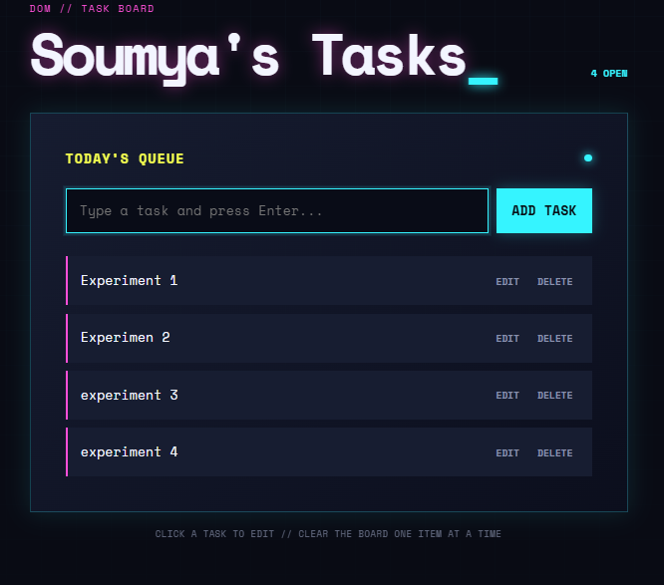

RESULT:

The To-Do application successfully performs real-time client-side task management with full CRUD capability without requiring page reloads. Users can dynamically generate new task items, edit existing task text through an inline input field, delete items instantly from the DOM tree, and toggle completion states via checkboxes to visually strike through finished tasks.

CASE STUDY 7
AIM:
To Demonstrate the Events Handling in JavaScript a) Access and manipulate form elements using JavaScript. b) Validate user input (e.g., email, empty fields). c) Use various form events (submit, change, focus). Create the following HTML form and use required JavaScript and events in a given form.
PROGRAM CODE:
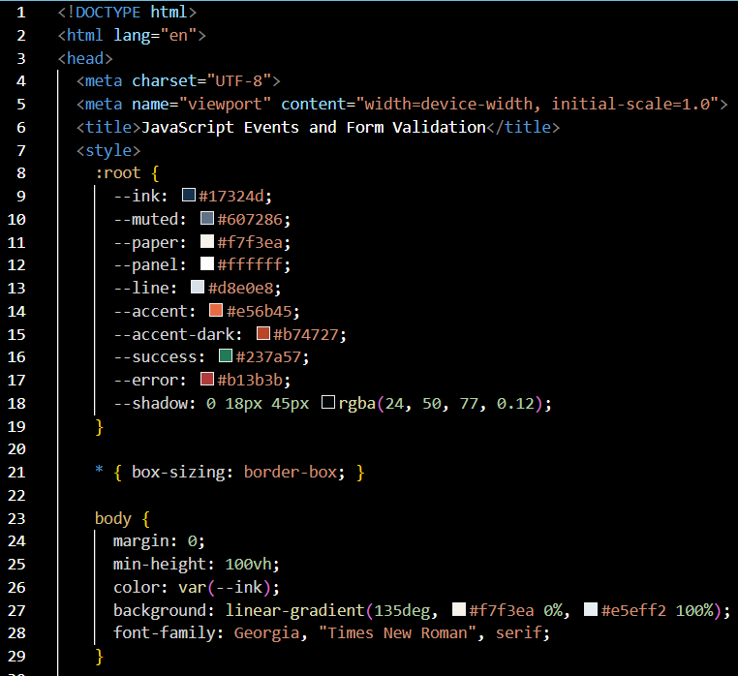
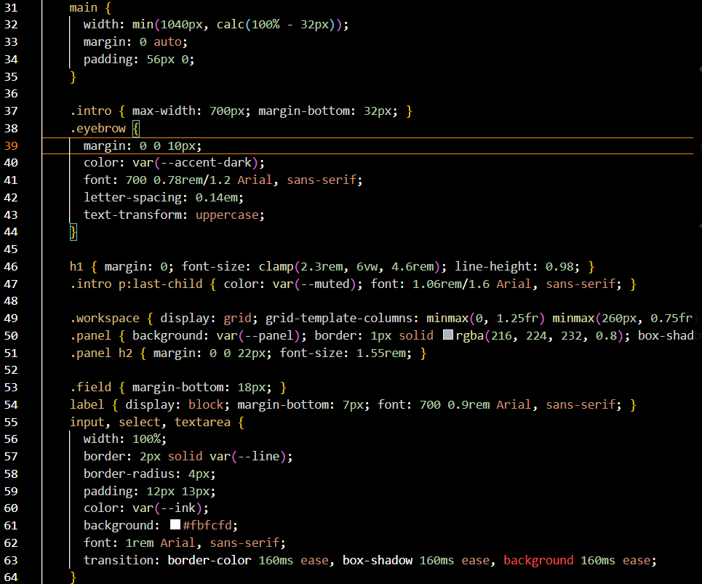
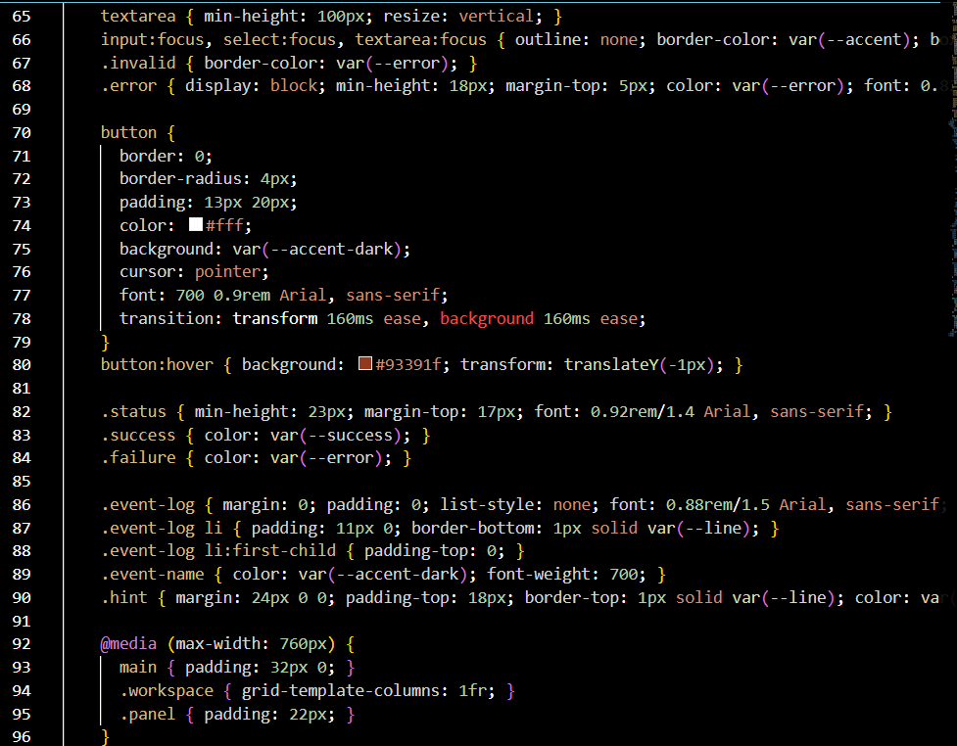
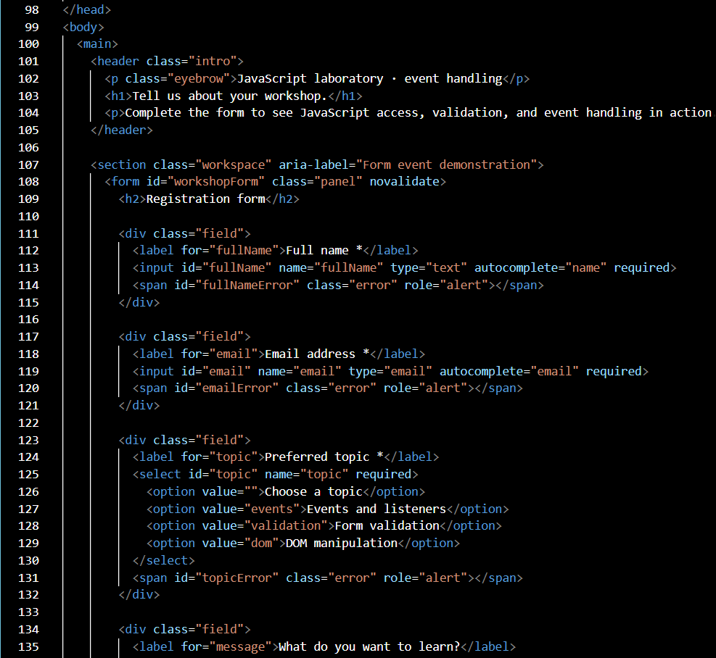
OUTPUT:
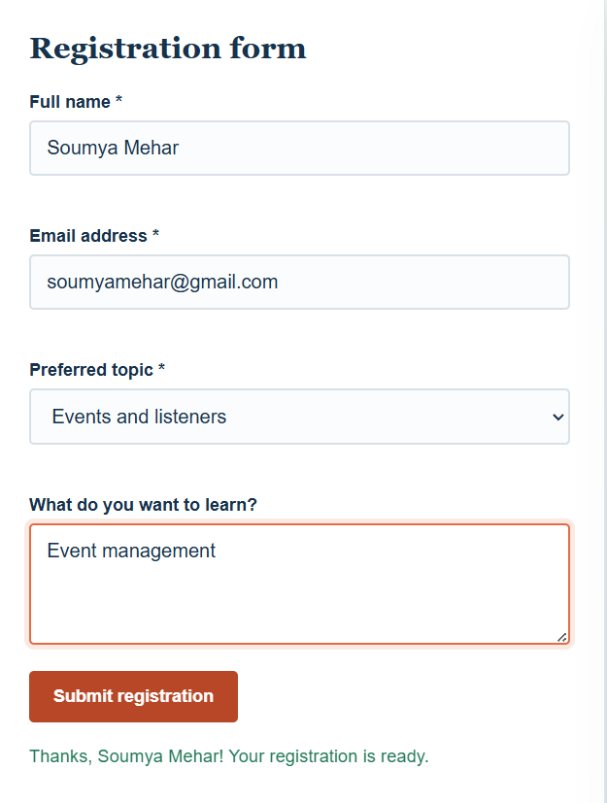
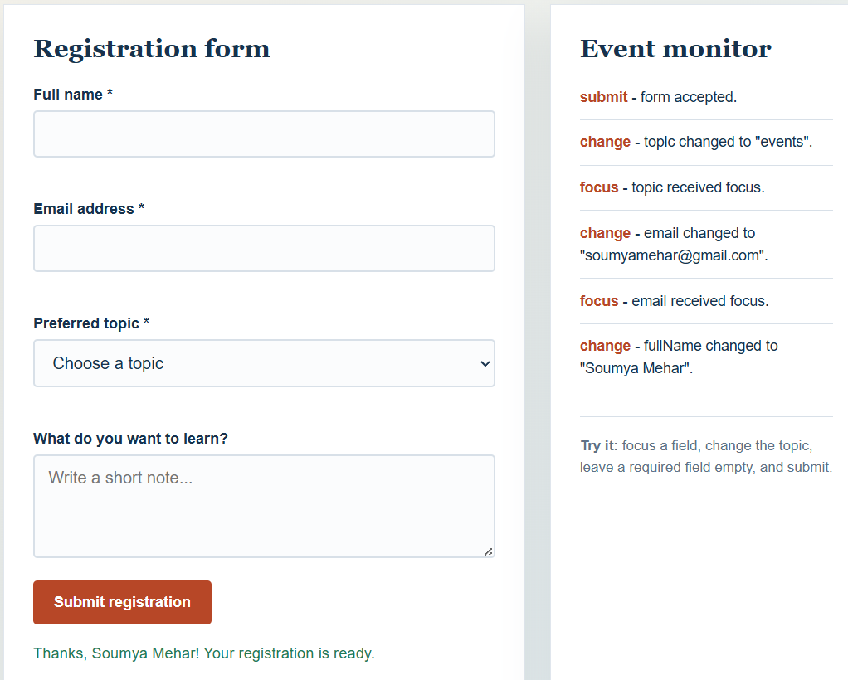
RESULT:
The HTML form was successfully created using JavaScript event handling. The form elements were accessed and validated using JavaScript, and focus, change, and submit events were successfully implemented.

EXPERIMENT 8
AIM:
Access and validate form fields using events; design a gym admission form with live input checks.
THOERY:
Forms: An HTML form collects user data using input fields, dropdowns, and checkboxes. JavaScript accesses these fields using getElementById and reads their values for processing and validation.
Events: An event is an action performed by the user, such as typing or clicking. Common events used are input (live typing), blur (leaving a field), change (select/checkbox), and submit (form submission). Event listeners allow JavaScript to respond immediately.
Form Validation: Validation checks whether entered data is correct and complete. It includes required checks, format checks (email, phone), range checks (age, fees), and logical checks (fees paid ≤ fees due). Invalid data shows error messages; valid data allows submission.
Live Input Checking: Live validation means checking fields as the user types using the input event, instead of waiting until submit. This improves accuracy and user experience.
preventDefault(): The preventDefault() method stops the form from reloading the page on submit so custom validation and messages can be shown.
Gym Admission Form: This form collects personal details, membership plan, fees to be paid, fees paid at registration, and emergency contact details. Each field is validated using events before the application is accepted.

OUTPUT:
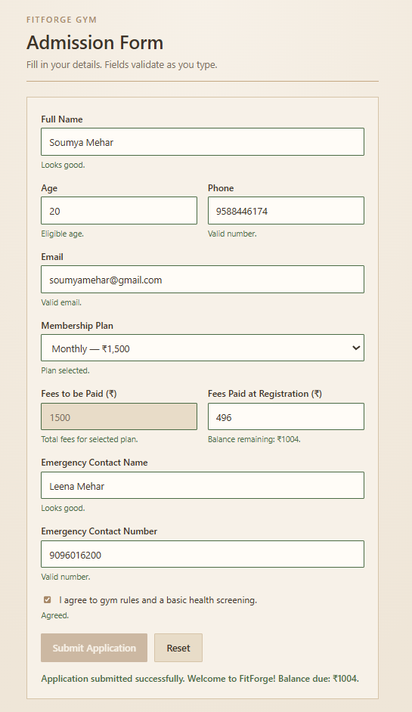
RESULT:
The concepts of accessing form fields and validating user input using JavaScript events were successfully implemented. A Gym Admission Form was developed with live input checks that correctly validates personal details, membership fees, and emergency contact information before submission.

CASE STUDY 8
AIM:
Create an Online Job Application Form Using Javascript.
PROGRAM CODE:
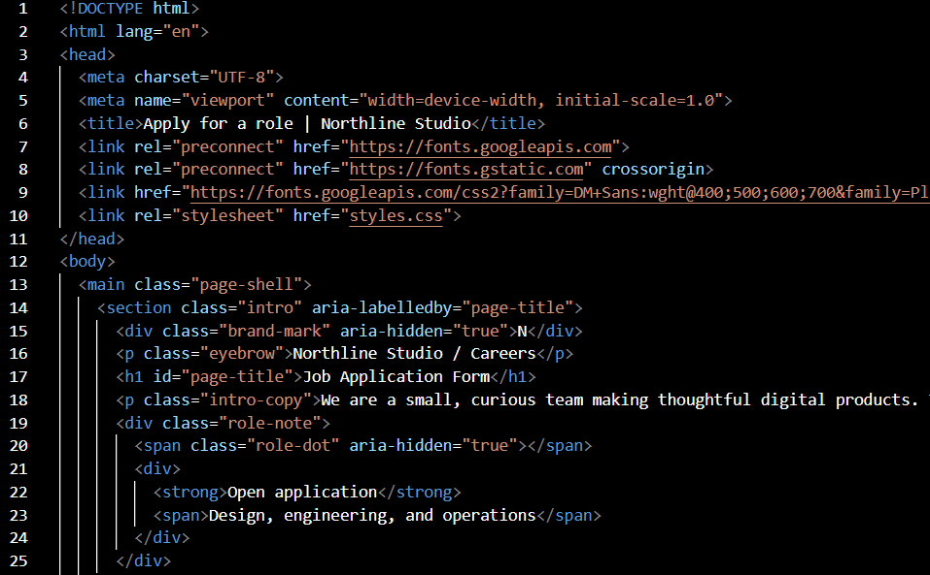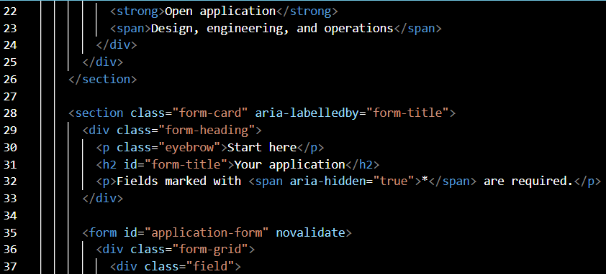
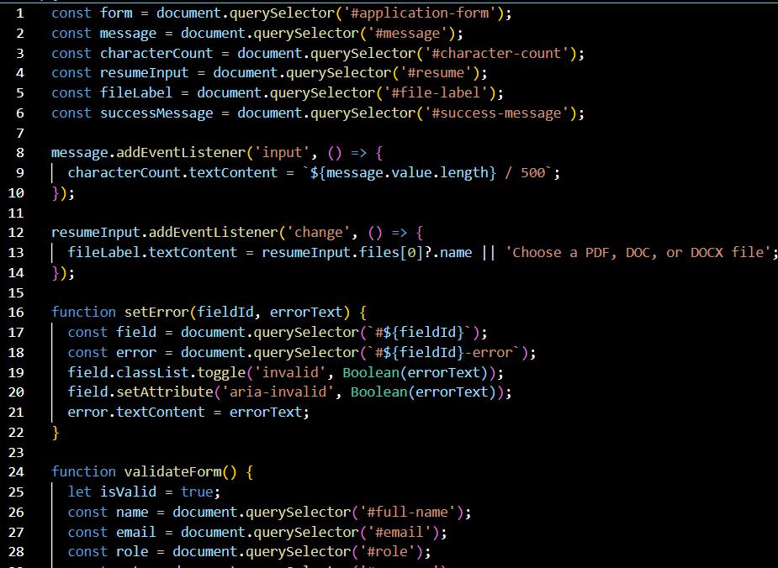
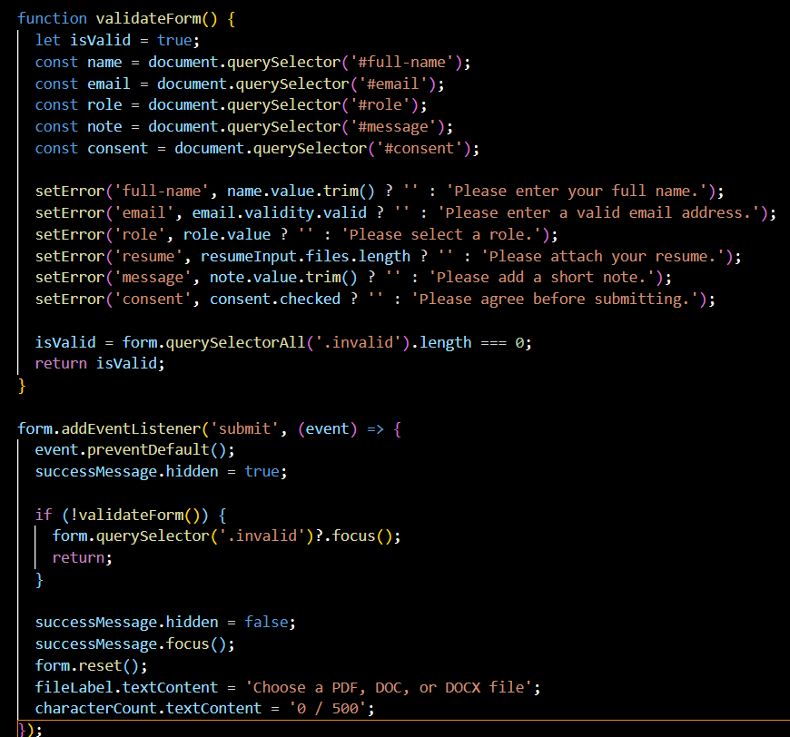
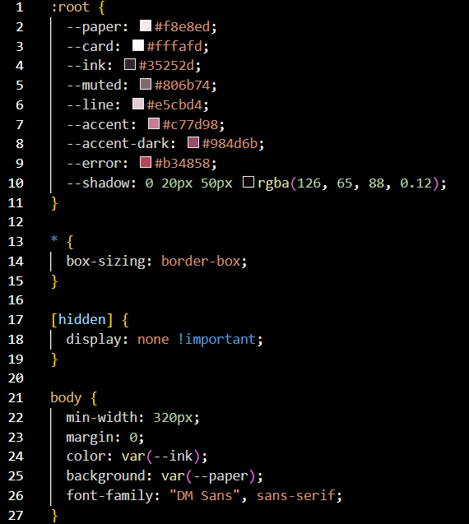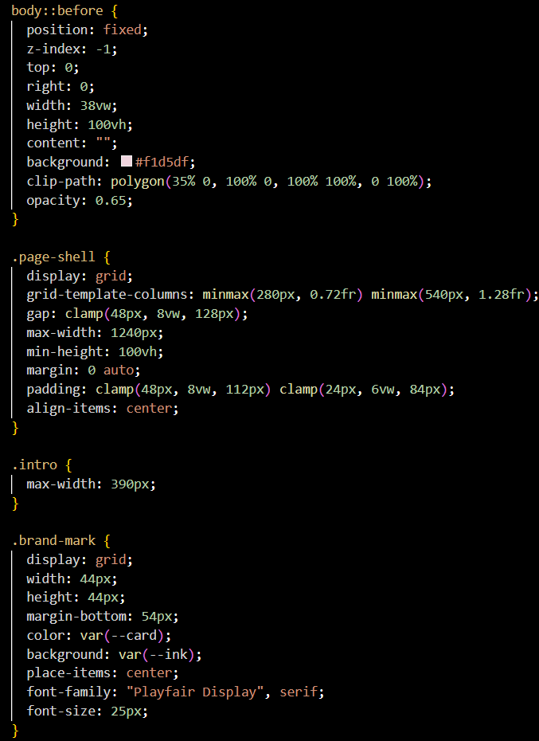
OUTPUT:
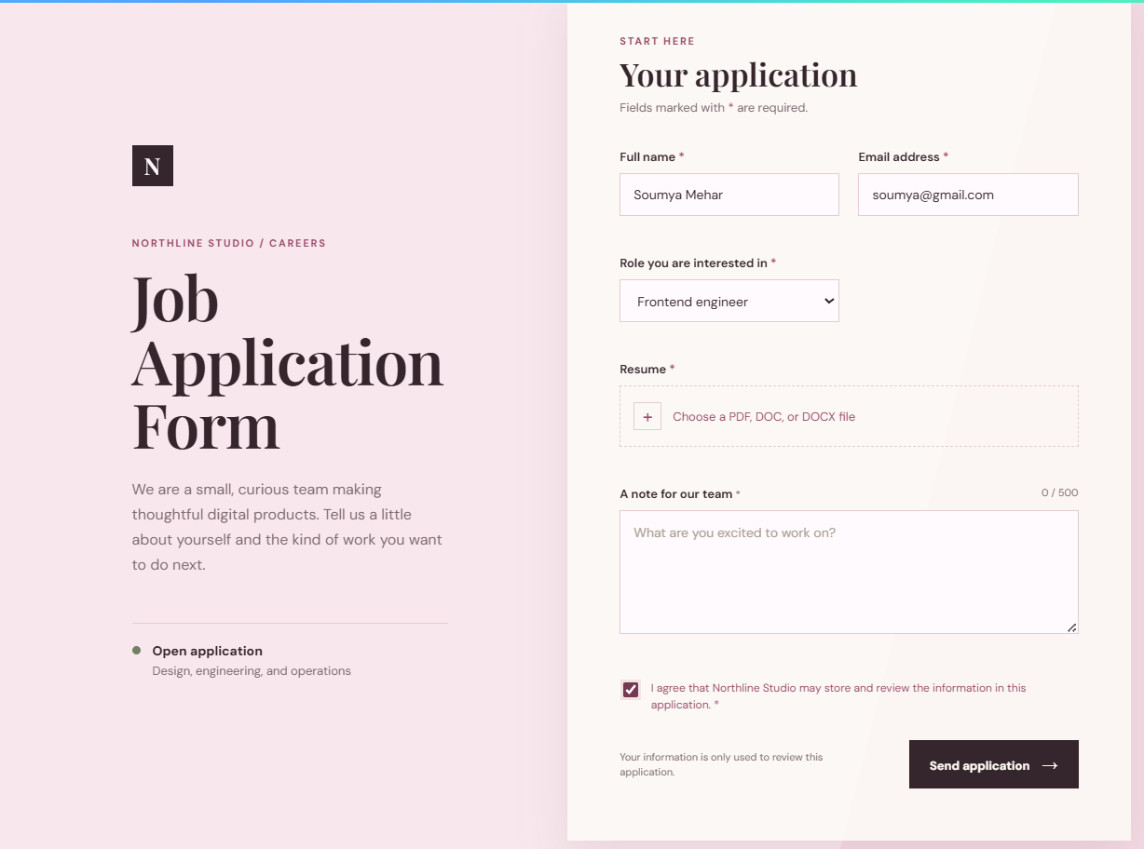
RESULT:
The Online Job Application Form was successfully created using HTML, CSS, and JavaScript. JavaScript was used to validate the applicant’s personal, contact, and educational details before submission. The form checks whether the entered information is valid and displays appropriate messages for incorrect or missing details. Thus, the case study demonstrates how JavaScript can be used for form validation, error handling, and creating an interactive web based application form.

EXPERIMENT 9
AIM:
Implement localStorage and sessionStorage to save user preferences like theme settings.
THEORY:
Web Storage API: The Web Storage API allows web applications to store data directly in the user's browser. It provides two main storage mechanisms: localStorage and sessionStorage.
localStorage: localStorage is used to store data persistently in the browser. The stored data remains available even after refreshing the webpage or closing and reopening the browser. In this practical, it is used to save user preferences such as theme and font size.
sessionStorage: sessionStorage is used to store temporary data for the current browser tab or session. The data remains available during page refreshes but is cleared when the browser tab is closed. In this practical, it is used to store the username of the current session.
Key-Value Pair: Both localStorage and sessionStorage store data in the form of key-value pairs. A key identifies the stored data and its value contains the actual information. For example, "theme" can be the key and "dark" can be its value.
setItem(): The setItem() method is used to store data in browser storage. For example, localStorage.setItem("theme", "dark") stores the selected dark theme.
getItem(): The getItem() method is used to retrieve previously stored data. For example, localStorage.getItem("theme") retrieves the saved theme preference.
removeItem(): The removeItem() method is used to delete a specific item from storage. It is used in this practical to remove saved preferences or session information.
User Session: A user session represents the current interaction of a user with the webpage. The username is stored using sessionStorage so that it remains available during the current browser session.
Storage Information: The application displays the currently stored theme, font size, and username. JavaScript retrieves these values from localStorage and sessionStorage and dynamically updates the webpage.
Reset Feature: The reset feature removes the saved theme and font-size preferences from localStorage using removeItem() and restores the default settings.
Clear Session Feature: The clear session feature removes the username from sessionStorage using removeItem() and ends the current session displayed by the application.
OUTPUT:
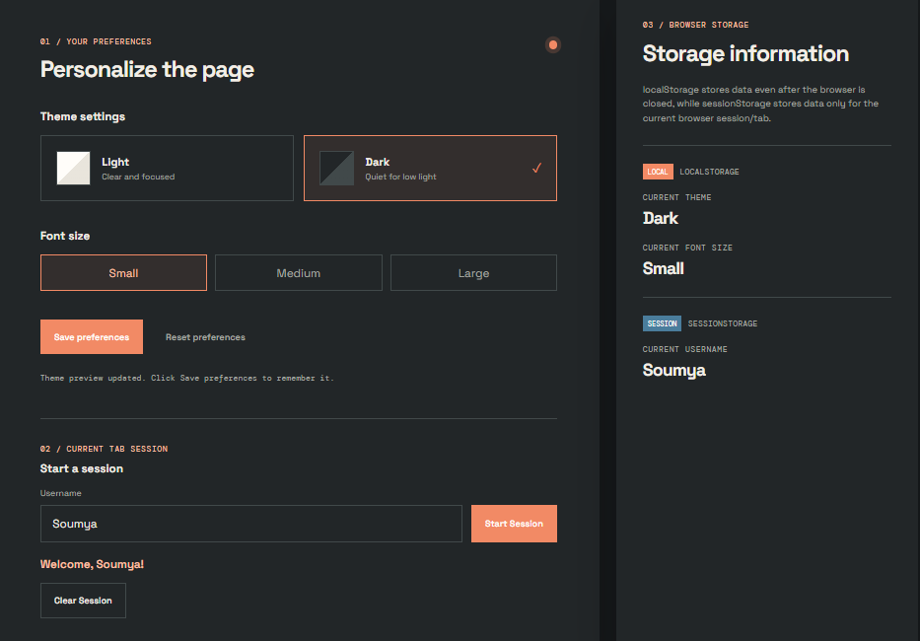

RESULT:
The web application was successfully implemented using JavaScript localStorage and sessionStorage. User preferences such as theme and font size were stored persistently using localStorage, while the username was stored temporarily using sessionStorage. The application also provided features to retrieve, update, reset, and clear the stored data dynamically.

EXPERIMENT 10
AIM:
Load and display JSON data using fetch() and jQuery $.getJSON(); render results dynamically in a table.
THEORY:
JSON (JavaScript Object Notation) is a lightweight format used to store and exchange data between a server and a web application. It represents data in a structured format that is easy for humans to read and machines to process. The Fetch API is a modern JavaScript method used to request data from an external API. It retrieves JSON data using the fetch() function and converts the response into a JavaScript object using response.json(). jQuery getJSON() is a jQuery method used to load JSON data from a server. It simplifies the process of requesting and handling JSON responses. In this practical, JSON data is fetched from an API using both Fetch API and jQuery getJSON(). The retrieved user information, such as ID, name, username, and email, is displayed dynamically in an HTML table using JavaScript. The table is updated by creating rows and inserting the data into the table body. This practical demonstrates how web applications retrieve external data, process JSON responses, and display information dynamically without manually entering each table row.

OUTPUT:


RESULT:
In this practical, we learned how to fetch and load JSON data using the Fetch API and jQuery getJSON(). The retrieved data was displayed dynamically in an HTML table using JavaScript. This practical helped us understand API data handling, JSON parsing, and dynamic content rendering in web development.

